**Count Vectorizer, Bag Of Words, TF-IDF**These are all important concepts in natural language processing (NLP) and text analysis. I'll explain each one concisely:

1. Bag of Words (BoW):
   * A simple text representation method
   * Counts word occurrences in a document, disregarding grammar and word order
   * Creates a vocabulary of unique words and represents documents as vectors of word counts
2. CountVectorizer:
   * A scikit-learn class that implements the Bag of Words model
   * Converts a collection of text documents into a matrix of token counts
   * Can be configured to exclude stop words, set maximum features, and use n-grams
3. TF-IDF (Term Frequency-Inverse Document Frequency):
   * A numerical statistic reflecting the importance of a word in a document within a collection
   * TF (Term Frequency): How often a word appears in a document
   * IDF (Inverse Document Frequency): Logarithm of (total documents / documents containing the word)
   * TF-IDF score = TF * IDF
   * Gives higher weight to words that are frequent in a document but rare across the corpus

Key differences:

* BoW and CountVectorizer focus on raw frequency, while TF-IDF considers relative importance
* TF-IDF often performs better for tasks like information retrieval and text classification

**Example**

Certainly! Let's walk through an example using a small corpus of three short documents to illustrate Bag of Words, CountVectorizer, and TF-IDF.

Our corpus:

1. "The cat sat on the mat."
2. "The dog chased the cat."
3. "The bird flew over the mat."

Let's apply each method to this corpus:

1. **Bag of Words (BoW) / CountVectorizer:**

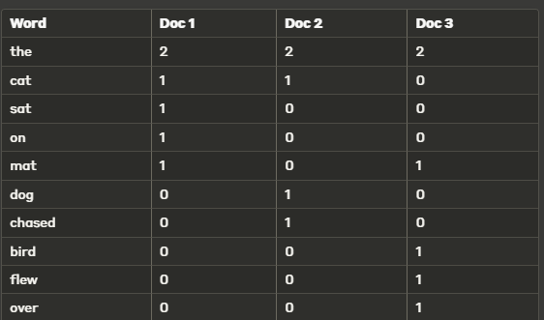

1. **TF-IDF:**

Now let's calculate TF-IDF for a few words:

a) "the" (appears in all documents): TF = 2/6 (for each document) IDF = log(3/3) = 0 TF-IDF = 2/6 * 0 = 0

b) "cat" (appears in 2 documents): TF = 1/6 (for Doc 1 and Doc 2), 0 (for Doc 3) IDF = log(3/2) ≈ 0.176 TF-IDF ≈ 0.029 (for Doc 1 and Doc 2), 0 (for Doc 3)

c) "bird" (appears in 1 document): TF = 1/6 (for Doc 3), 0 (for Doc 1 and Doc 2) IDF = log(3/1) ≈ 0.477 TF-IDF ≈ 0.080 (for Doc 3), 0 (for Doc 1 and Doc 2)

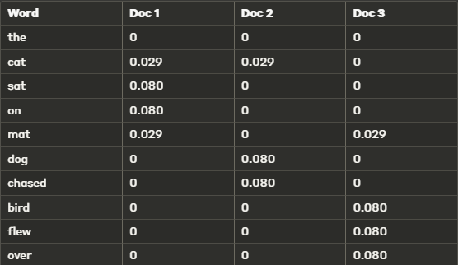

Key observations:

1. Common words like "the" have a TF-IDF score of 0 because they appear in all documents.
2. Unique words like "bird" or "dog" have higher TF-IDF scores because they appear in fewer documents.
3. TF-IDF gives higher weight to words that are frequent in a document but rare across the corpus.

Here’s a brief overview of each term:

1. **Correlation**:
   * **Definition**: Correlation measures the strength and direction of a linear relationship between two variables. It ranges from -1 to 1.
     + **Positive Correlation**: As one variable increases, the other also increases (e.g., height and weight).
     + **Negative Correlation**: As one variable increases, the other decreases (e.g., price of an item and its demand).
   * **Measurement**: Often quantified using Pearson’s correlation coefficient, but other types (like Spearman’s rank correlation) are used for non-linear relationships.
2. **Collinearity**:
   * **Definition**: Collinearity refers to a situation where two independent variables in a regression model are highly correlated. This means that they provide overlapping information about the variance of the dependent variable.
   * **Implication**: Collinearity can make it difficult to determine the individual effect of each variable on the dependent variable.
3. **Multicollinearity**:
   * **Definition**: Multicollinearity occurs when three or more independent variables in a regression model are highly correlated. This extends the concept of collinearity to multiple variables.
   * **Implication**: It can cause problems such as inflated standard errors, leading to unreliable estimates of coefficients and difficulties in determining the individual effect of each variable. It can also affect the stability of the model's estimates.

**How to Detect**:

* **Correlation Matrix**: Helps in visualizing the correlations between variables.
* **Variance Inflation Factor (VIF)**: Measures how much the variance of a regression coefficient is inflated due to multicollinearity.
* **Condition Index**: Part of diagnostic tools that can help identify multicollinearity.

**How to Address**:

* **Remove Variables**: If variables are highly correlated, consider removing or combining them.
* **Principal Component Analysis (PCA)**: Can be used to reduce dimensionality and address multicollinearity.
* **Regularization Techniques**: Methods like Lasso or Ridge regression can help manage multicollinearity by adding penalties to the coefficients.

**Feature Scaling in K-Means**

Yes, **feature scaling** has a significant impact on the **K-means algorithm**. Since K-means is a distance-based algorithm, the **Euclidean distance** used to calculate the distance between data points is sensitive to the scale of the features.

**Why Feature Scaling Matters in K-means:**

1. **Distance Calculation**:
   * K-means uses **Euclidean distance** to assign data points to the nearest cluster centroid. Features with larger ranges or units can dominate the distance calculations, even if they are not inherently more important. This skews the clustering results, as K-means will give more weight to features with larger values.
2. **Effect on Centroid Assignment**:
   * Without scaling, features with larger values will disproportionately influence how centroids are computed. This means that features with smaller ranges (or different units) may be ignored, leading to poor clustering results.

**Example:**

Suppose you have a dataset with two features:

* **Feature 1**: Income (range from 10,000 to 100,000).
* **Feature 2**: Age (range from 20 to 80).

Without scaling, the income feature would dominate the Euclidean distance because its range is much larger than the age feature. This means K-means would prioritize clustering based on income, while ignoring age to a large extent.

**Key Takeaways:**

* **Scaling is crucial** for K-means because of its reliance on distance metrics.
* If features are not scaled, those with larger ranges will dominate the clustering results.
* **Standardization** and **Min-Max Scaling** are common methods to scale features, depending on whether you want the features to have a mean of 0 and standard deviation of 1 (standardization) or to be scaled within a fixed range (min-max scaling).

**Clustering For Mix of Numerical and Categorical Data**

If you have a **mix of numerical and categorical data**, the best algorithm to use is the **K-prototypes algorithm**. This algorithm is specifically designed to handle datasets with both types of features by combining the strengths of **K-means** (for numerical data) and **K-modes** (for categorical data).

**Why Use K-prototypes:**

1. **Numerical Data Handling**: It uses **Euclidean distance** to compute similarities between numerical features, similar to how K-means works.
2. **Categorical Data Handling**: It uses a **simple matching dissimilarity** measure for categorical features, as K-modes does. This means that categorical variables are compared by whether their values match (same value = 0, different value = 1).
3. **Cluster Centroids**: For numerical features, the cluster centroid is the mean value, and for categorical features, the centroid is the most frequent category (mode).

**How K-prototypes Works:**

* For **numerical features**, the distance is calculated using Euclidean distance.
* For **categorical features**, the distance is calculated using a simple mismatch metric (0 if the values are the same, 1 if they are different).
* The algorithm combines these distances to form clusters, taking into account both numerical and categorical data.

**Other Considerations:**

* **Preprocessing**: Before using K-prototypes, you may need to ensure that categorical variables are correctly encoded as strings or object types.
* **Scaling**: Since numerical data can have different ranges, it is often a good idea to **scale** the numerical features (e.g., using **StandardScaler** or **MinMaxScaler**) before clustering.

**AUC-PR over AUC-ROC For Imbalanced DataSets**

The Area Under the Precision-Recall Curve (AUC-PR) is often considered better than the AUC-ROC for evaluating model performance on imbalanced datasets because it focuses more on the minority class (positive class), which is usually of greater interest in such cases. Let’s dive into the details:

### 1. ****What is AUC-PR?****

The **Precision-Recall Curve (PR curve)** plots **Precision** (y-axis) against **Recall** (x-axis) for different thresholds of classification probability. Precision focuses on the correctness of the positive predictions, while recall focuses on how well the model captures all actual positives.

* **Precision**: How many of the predicted positives are true positives.
* **Recall**: How many of the actual positives are correctly predicted by the model.

The **Area Under the Precision-Recall Curve (AUC-PR)** is the area under this curve and summarizes the trade-off between precision and recall for different thresholds.

### 2. ****Why is AUC-PR Better for Imbalanced Datasets?****

In imbalanced datasets, the number of positive cases (the minority class) is much smaller than the number of negative cases. This creates a few challenges:

#### **2.1 AUC-ROC vs. AUC-PR in Imbalanced Data**

* **AUC-ROC** considers both true positive rate (recall) and false positive rate. The **false positive rate** is defined as:
  + - 

When the dataset is highly imbalanced, the **true negatives** (majority class) dominate the denominator of the FPR. Even if the model predicts the majority class (negative) very well, the false positive rate will remain small because the negative cases are overwhelmingly more numerous, making the ROC curve look deceptively good, despite poor performance on the minority class.

* **AUC-PR**, on the other hand, focuses solely on the positive class (true positives and false positives). It doesn't involve the true negatives at all, which means it won't be skewed by the imbalance in negative samples. A high AUC-PR indicates that the model is able to identify the minority class (positive class) with high precision and recall.

#### 2.2 **Precision and Recall are More Sensitive to the Positive Class**

* **Precision** is highly sensitive to false positives, and false positives are more likely in imbalanced datasets because the model tends to predict the majority class more often.
* **Recall** measures how many of the actual positive cases the model can capture, which is critical for imbalanced datasets because identifying the minority class is often the goal.

In imbalanced datasets, a high precision ensures that when the model predicts a positive case, it is more likely to be correct. A high recall ensures that the model captures most of the true positive cases. The AUC-PR curve captures this trade-off between precision and recall more effectively.

### 3. ****Example****

Suppose you are building a model to predict a rare disease in a medical dataset where only 1% of the patients have the disease (the positive class). Your dataset is highly imbalanced.

* **AUC-ROC** could give you a very high score (e.g., 0.95) simply because the model is good at predicting the majority class (no disease). But, since there are so many true negatives, the false positive rate remains low, even if the model misses most of the actual positive cases (the patients with the disease).
* **AUC-PR**, in contrast, would give a more accurate reflection of the model's performance. If your precision is low (the model predicts a lot of false positives), and recall is also low (the model misses many actual cases), the AUC-PR will clearly show this, as both precision and recall will drop. This gives you a better idea of how well your model is actually performing on the minority class.

### 4. ****Visualizing the Difference****

* **AUC-ROC Curve**: The x-axis shows the false positive rate (which can remain small due to the large number of negatives), while the y-axis shows the true positive rate (recall).
* **Precision-Recall Curve**: The x-axis shows recall, and the y-axis shows precision, which directly focuses on the positive class performance without considering the majority class (negatives).

In imbalanced datasets, ROC curves can still show high performance due to a low false positive rate driven by the large number of true negatives, even when the minority class is poorly predicted. PR curves don’t have this issue because they highlight the model's ability to correctly classify the minority class, which is often the target in real-world applications.

### 5. ****Conclusion****

The **AUC-PR** is more **informative and reliable** for imbalanced datasets because:

* It **doesn’t get inflated by the true negative cases** (majority class).
* It better reflects how well the model performs on the **minority class**.
* It emphasizes the **trade-off between precision and recall**, which is crucial when false positives or false negatives are costly (e.g., fraud detection, rare disease prediction).

For these reasons, AUC-PR is often the **preferred metric** for imbalanced datasets, especially when the focus is on improving performance for the minority class.

**Residual Plots:**

A **residual plot** is a graphical tool used to assess the fit of a regression model. It plots the residuals (the differences between the actual and predicted values) on the y-axis and the predicted values (or sometimes the independent variable) on the x-axis.

**Key Elements:**

1. **Residuals**: These are the differences between observed and predicted values (actual - predicted).
2. **X-axis**: This can represent either the predicted values or one of the independent variables.
3. **Y-axis**: The residuals.

**Interpretation of Residual Plots:**

1. **Random Scatter**: If the residuals are randomly scattered around zero, it indicates that the model is capturing the underlying relationship well.
2. **Patterns**: Any visible patterns (e.g., curves, trends) in the residual plot suggest that the model may not be appropriate. This can indicate non-linearity or other problems with model assumptions.
3. **Heteroscedasticity**: If the spread of the residuals increases or decreases with the predicted values, this suggests **heteroscedasticity** (non-constant variance), which can be problematic for regression models.

**Example:**

If you're fitting a linear regression model, after generating the predictions, the residual plot should look like a random cloud of points centered around zero. If you see a funnel shape or a curve, this suggests the model might not be appropriate (e.g., missing non-linear relationships).

**Smote**

SMOTE (Synthetic Minority Over-sampling Technique) is a technique used to handle class imbalance in machine learning. It creates synthetic samples for the minority class to balance the dataset, improving model performance on minority class predictions.

Here's a breakdown of how SMOTE works:

1. **Identify Minority Class Samples**:
   * SMOTE targets the minority class in the dataset (e.g., fraudulent transactions or disease cases) which often has far fewer samples than the majority class.
2. **Select a Sample and Find Neighbors**:
   * For each sample in the minority class, SMOTE finds its *k-nearest neighbors* (other samples in the minority class) based on a distance metric, often Euclidean distance for continuous data.
3. **Generate Synthetic Samples**:
   * SMOTE selects a neighbor at random and generates a synthetic sample by interpolating between the two points. This is done by adding a fraction of the distance between the sample and its neighbor to the original sample, creating a new data point somewhere along this line.

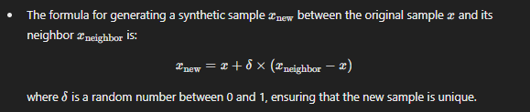

1. **Repeat for All Minority Class Samples**:
   * This process is repeated until the minority class has as many samples as desired, effectively balancing the dataset.

**Benefits of SMOTE**

* **Improves Model Performance on Minority Class**: By adding synthetic samples, SMOTE increases the representation of the minority class, helping the model learn patterns specific to it.
* **Avoids Overfitting**: Unlike simple duplication, SMOTE’s synthetic samples introduce slight variations, reducing the risk of overfitting to exact copies of minority class samples.

**Limitations of SMOTE**

* **Sensitive to Noise**: SMOTE can generate synthetic samples near noisy samples (outliers), which might reduce model accuracy.
* **Works Best with Continuous Data**: SMOTE is most effective on numerical data and may not handle categorical data well (although SMOTE-ENC helps address this by combining techniques for mixed data types).

In summary, SMOTE is a widely used resampling method that’s especially effective in improving model performance on imbalanced datasets, particularly when dealing with continuous features.

**K-means ++ Initialization**

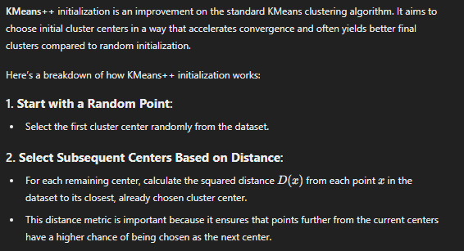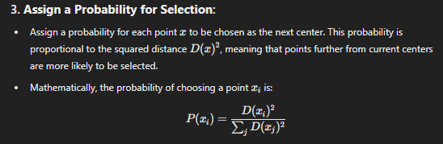

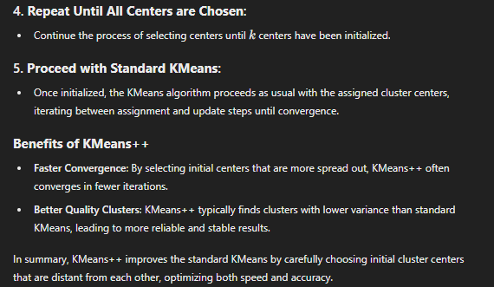

**Out of Bag (OOB) error** is a concept used in ensemble learning, specifically with **Bagging** techniques like **Random Forests**. It provides an internal method of estimating the prediction error of the model without requiring a separate validation set or performing cross-validation.

**How Out of Bag Error Works:**

1. **Bootstrap Sampling**: In bagging, multiple decision trees (or models) are trained on different subsets of the training data. These subsets are created using **bootstrap sampling**, which means that for each tree, a random sample is taken from the training data **with replacement**. As a result, some data points are repeated in the sample, while others are left out.
2. **OOB Samples**: The data points that are not included in the bootstrap sample for a particular tree are called **out-of-bag (OOB) samples**. On average, about **one-third of the original training data** is left out of the sample for any given tree.
3. **Error Calculation**:
   * Each tree is tested on its corresponding OOB samples, i.e., the data points that were not used to train that particular tree.
   * The predictions for these OOB samples are recorded.
   * Once all trees have made predictions for their OOB samples, the **OOB error** is computed by aggregating these predictions and comparing them to the true values of the OOB samples.

**Formula for OOB Error:**

If you have N training instances and you're training a random forest with T trees, then for each instance i, you get a prediction from the trees that did not include i in their bootstrap sample. The OOB error is the proportion of misclassified OOB samples, calculated as:

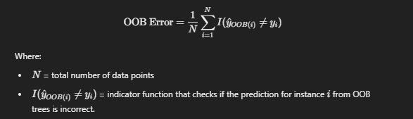

**Why OOB Error is Useful:**

* **No Need for a Separate Validation Set**: OOB error provides an unbiased estimate of the generalization error without needing to split the data into a separate validation set.
* **Efficient**: Since it uses data already available during training, it doesn’t require additional computation like cross-validation does.
* **Generalization Estimate**: The OOB error is considered a reliable estimate of the model's test error, particularly for Random Forests.

**Example in Random Forest:**

In a Random Forest, which is a collection of decision trees trained on bootstrap samples of the data, the OOB error is often calculated to evaluate the model’s performance. During training, the algorithm doesn’t need to allocate a separate portion of the data for validation; instead, it uses the OOB samples to compute an estimate of how well the model will generalize.

**Pros of OOB Error:**

* **Efficient**: Saves time and data since it avoids cross-validation or using a separate validation set.
* **Unbiased**: Provides an unbiased estimate of the model’s test error.
* **Automatic**: Built-in feature of Random Forests, so you don’t need to manually implement cross-validation or hold-out sets.

**Summary:**

* **Out of Bag (OOB) Error** is an internal estimate of the model's prediction error in bagging methods like Random Forests.
* It uses the data not included in the bootstrap sample to test the performance of each tree.
* OOB error is an efficient, unbiased way to estimate the generalization error without needing a validation set or cross-validation.

This feature makes Random Forests a powerful tool for classification and regression tasks.

**Example Confusion Matrix for Overfitting Model**

An overfitting model often performs very well on the training data but poorly on unseen test data. Here's a simple example to illustrate this with a confusion matrix:

**Training Data Confusion Matrix (Overfitting Model)**

* **Predicted class**: Positive / Negative
* **Actual class**: Positive / Negative

|  |  |  |
| --- | --- | --- |
|  | Predicted Positive | Predicted Negative |
| Actual Positive | 95 | 5 |
| Actual Negative | 3 | 97 |

**Accuracy (Training Data)**: Very high (e.g., 96%)

The model captures most of the training patterns well.

Test Data Confusion Matrix (Overfitting Model)

|  |  |  |
| --- | --- | --- |
|  | **Predicted Positive** | **Predicted Negative** |
| Actual Positive | 40 | 60 |
| Actual Negative | 30 | 70 |

* **Accuracy (Test Data)**: Much lower (e.g., 55%)
* The model struggles to generalize, showing poor performance on new data.

This discrepancy between the training and test performance is a typical sign of overfitting.

Stemming and lemmatization are both techniques used in natural language processing (NLP) to reduce words to their base or root form. However, they differ in the way they perform this task:

**1. Stemming**

* **Definition**: Stemming is a rule-based process of removing suffixes from a word to reduce it to its base form (stem). The resulting word may not be a valid word or may not have meaning in the language.
* **Process**: It chops off the end of words using heuristic techniques, often without understanding the context or meaning.
* **Example**:
  + **"Caring"** → "Car"
  + **"Studies"** → "Studi"

In these examples, "car" and "studi" are not valid words in English, but stemming does not care about the linguistic correctness.

* **Common Algorithm**: Porter Stemmer, Snowball Stemmer.
* **Advantages**:
  + Simple and computationally efficient.
  + Fast and works well for simple tasks.
* **Disadvantages**:
  + Can lead to incorrect stems (e.g., "better" → "bet").
  + It doesn’t always produce meaningful words.

**2. Lemmatization**

* **Definition**: Lemmatization is a more advanced technique that reduces words to their base form (lemma) by considering the context and the meaning of the word. It requires knowledge of the part of speech (POS) of a word (whether it's a noun, verb, etc.).
* **Process**: It looks at the word's role in a sentence (its POS) and returns the correct base form based on the word's meaning.
* **Example**:
  + **"Caring"** → "Care"
  + **"Studies"** → "Study"
  + **"Better"** → "Good" (Here, lemmatization identifies "better" as the comparative form of "good").

In this case, lemmatization produces valid words with proper linguistic meaning.

* **Common Libraries**: WordNet Lemmatizer (from NLTK).
* **Advantages**:
  + More accurate and meaningful reductions.
  + Considers the word’s meaning and context.
* **Disadvantages**:
  + Computationally more expensive than stemming.
  + Requires more resources, including knowledge of the word's part of speech.

**Extreme Thresholds**

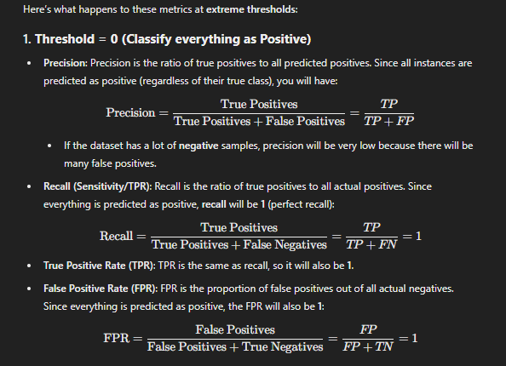

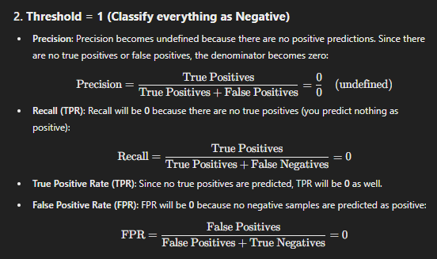

|  |  |  |
| --- | --- | --- |
| Metric | Threshold = 0 | Threshold = 1 |
| Precision | Low (depends on data, many FP) | Undefined (no positive predictions) |
| Recall (TPR) | 1 (all true positives predicted) | 0 (no true positives predicted) |
| True Positive Rate (TPR) | 1 (same as recall) | 0 (no true positives predicted) |
| False Positive Rate (FPR) | 1 (all negatives predicted as positives) | 0 (no false positives) |

**Soft margin** and **hard margin** refer to two approaches in **Support Vector Machines (SVMs)** when dealing with the separation of classes in classification tasks:

**Hard Margin SVM:**

* **Strict Separation**: In hard margin SVM, the model attempts to find a hyperplane that separates the data perfectly with no misclassifications.
* **Assumption**: It assumes that the data is linearly separable, meaning that there is a clear boundary between the classes.
* **No Slack Variables**: No tolerance for misclassification or points within the margin. All data points must be outside or on the boundary of the margin.
* **Limitation**: If the data is not perfectly separable (which is common in real-world scenarios), hard margin SVMs will fail to find a solution or overfit the data.

**Soft Margin SVM:**

* **Relaxed Separation**: Soft margin SVM allows for some misclassifications or points to be within the margin.
* **Slack Variables**: It introduces **slack variables** that allow some points to violate the margin or be misclassified. The idea is to balance maximizing the margin and minimizing misclassification.
* **Optimization**: The optimization problem in soft margin SVM minimizes both the size of the margin and the penalty for misclassified points.
* **Practical Use**: Soft margin is more commonly used because real-world data often has noise or is not perfectly separable. It allows for better generalization by balancing margin size and error tolerance.

**Key Difference:**

* **Hard margin** requires a perfect separation with no errors.
* **Soft margin** introduces flexibility, allowing some points to be within the margin or misclassified, making it more practical for noisy or non-separable data.